Lab Report

Name: | Thomas Farrell
Student Number: | 20083540
Lab (Week) Number: | 2
Date: | 16/09/24

Exercise 2.1
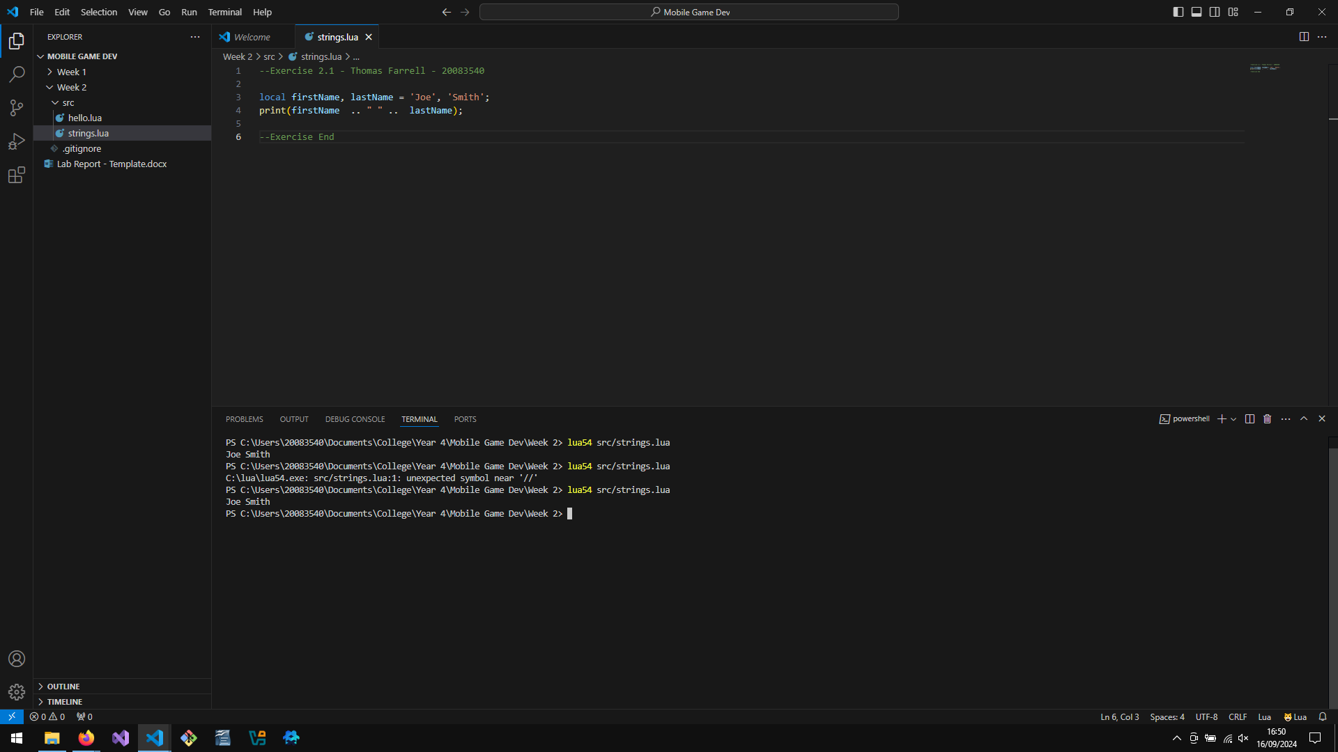

Exercise 3.1
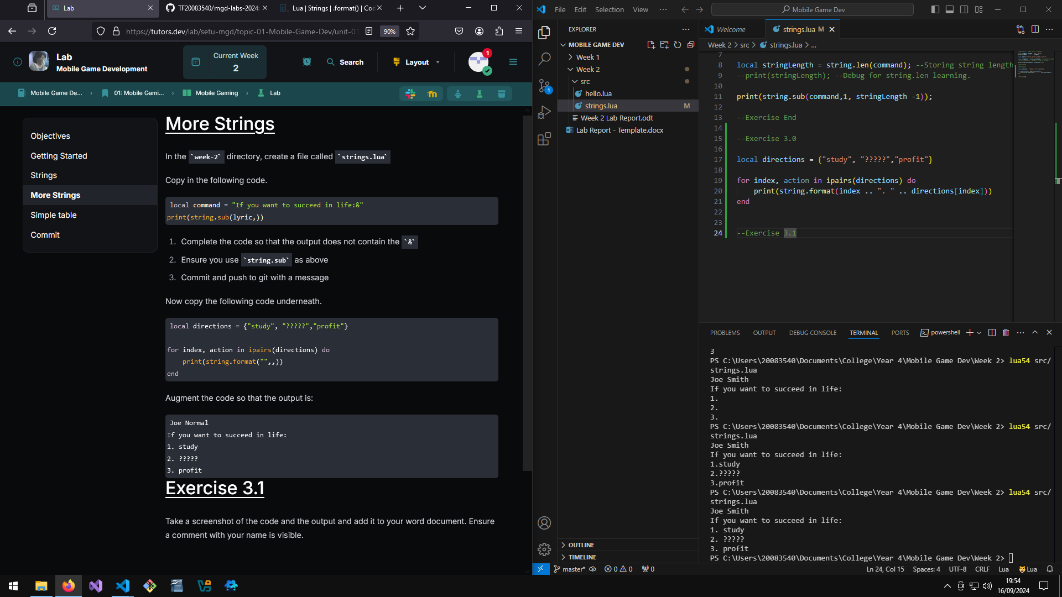

Exercise 4.1
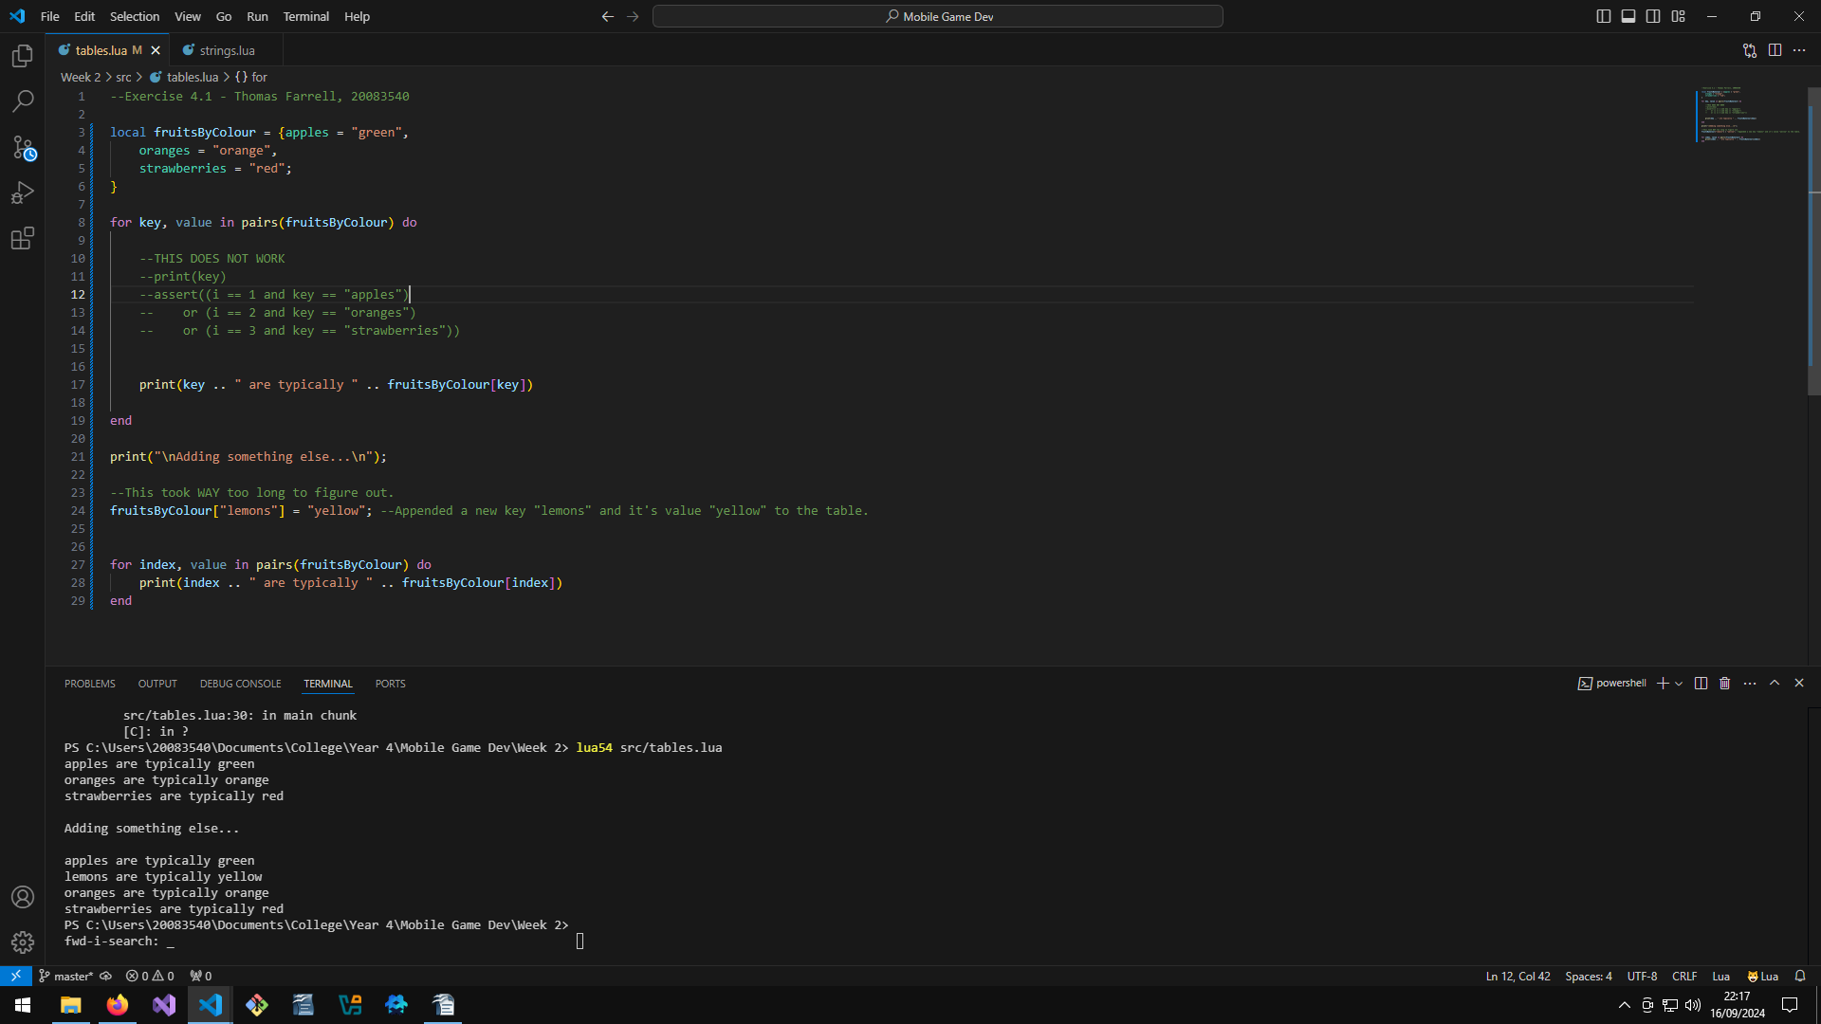

Conclusions (optional)
Inserting additional values into tables feels like it's done in a wrong, roundabout way. However, it does make sense after taking a pause to read it over.
Just wish the documentation explained it better, but i got there.

